Kertas Proejct, Disseration, and Thesis Submission Checklist –Version 2025

No | Items | Checklist | Remarks | Tick (✓)
1 | Front covering page | 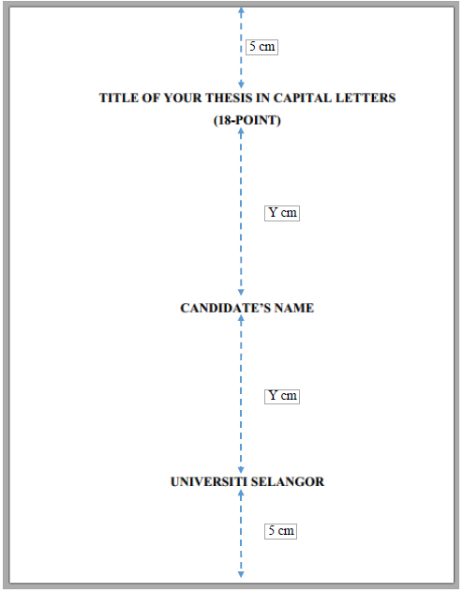 | - Title:  - 18 font size  - Capital  - The candidate’s name  - The name of the university (UNIVERSITI SELANGOR)  - The title must be grammatically correct and reflects the study undertaken.  - It should be clear and concise, and must not exceed 20 words or 15 substantove words. Abbreviations and acronyms should be avoided, except for commonly used in the field of study. The phrases that reflect research exercise should also be avoided such as ‘Analysis of...’, ‘A preliminary study of...’, ‘An investigation of...’ and ‘A theory of...’. For titles in Bahasa Melayu, the terms used must be found in Kamus Dewan for the relevant field of study.
2 | Blank page |  | - Compulsory, without page number
3 | Author’s Declaration | 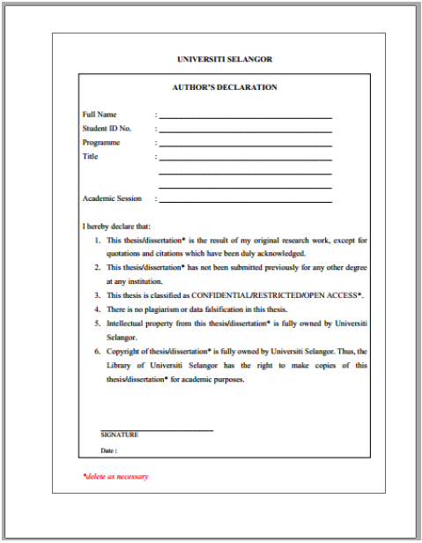 | - Signature  - Declaration of originality  - Classification of thesis/dissertation*  - Copyright statement (must choose one)  - Thesis is for the programme by research, dissertation is for for programme by coursework
4 | Supervisor’s Declaration | 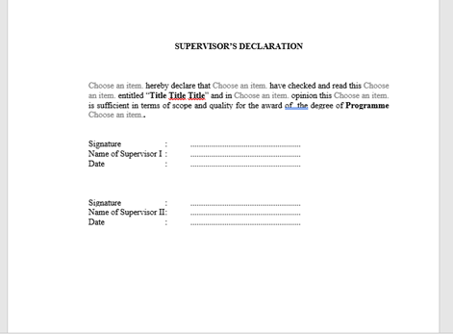 | - Supervisor(s)’s signature  - Use I if only one supervisor or We if more than one supervisor
5 | Title Page | 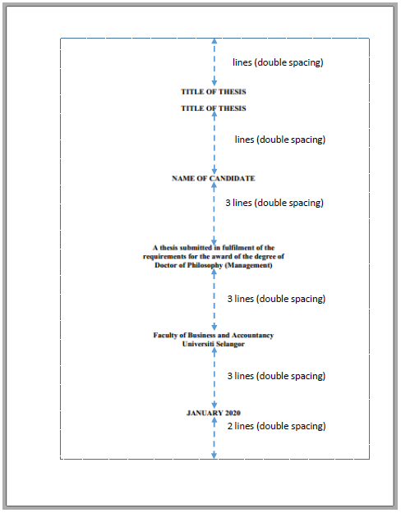 | - Month and Year of Submission
6 | Acknowledgement | I | - Write the full name of to whom you are thanking if an academician  - Not exceed one page

7 | Abstract/ Abstrak |  | Contain  - Written in one paragraph.  - Uses single spacing.  - Does not exceed 500 words.  - Provides a brief summary of:  - The problem statement  - The objectives of the study  - The research methodology adopted  - The major findings  - The conclusions  - The contribution of the study  - Gives a complete yet concise understanding of the research and findings.  - ll abbreviations and acronyms are preceded by their full terms at first use.  - Written in both English and Bahasa Melayu.  - The version that matches the thesis language appears first.  - Both versions fit on one page.
8 | Table of Contents | Reference management software should be used  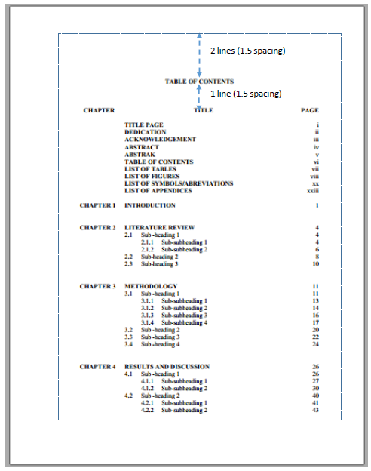 | - Page numbers must match those in the text.  - Use UNISEL’s format
9 | List of Tables | 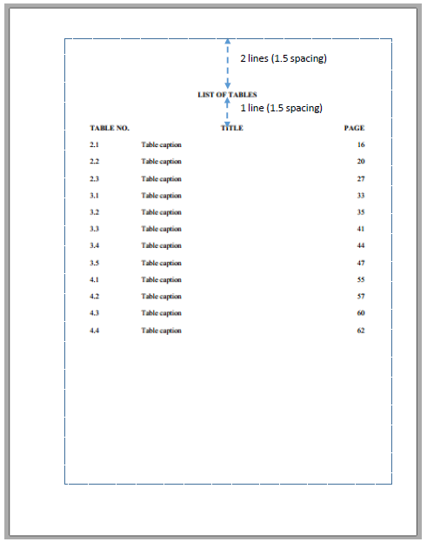 | - Titles must match captions in the texts of tables as written in the text  - Table numbering uses Arabic numerical system according to the chapter, e.g. Table 4.1
10 | List of Figures | 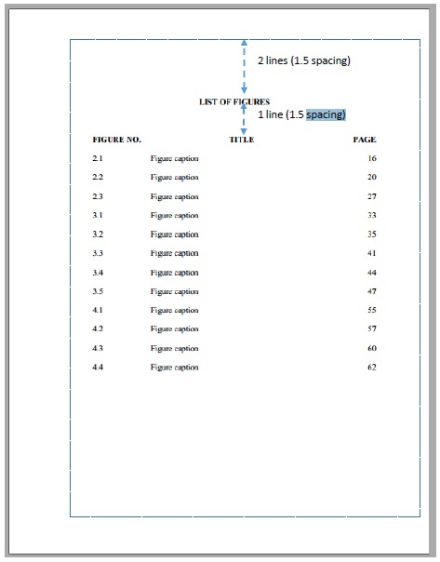 | - Titles must match captions in the texts of figures as written in the text  - Table numbering uses Arabic numerical system according to the chapter, e.g. Figure 4.1
11 | List of Symbols/Abbreviations | 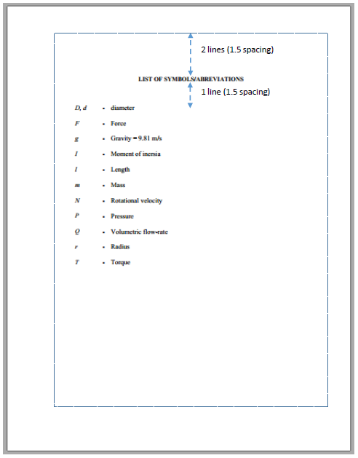 | - Arrange symbols and abbreviations alphabetically
12 | List of Appendices |  | - Appendices should be listed in the order that appear in the thesis.  - Labeled alphabetically (e.g., Appendix A, Appendix B)

13 | BodyText | 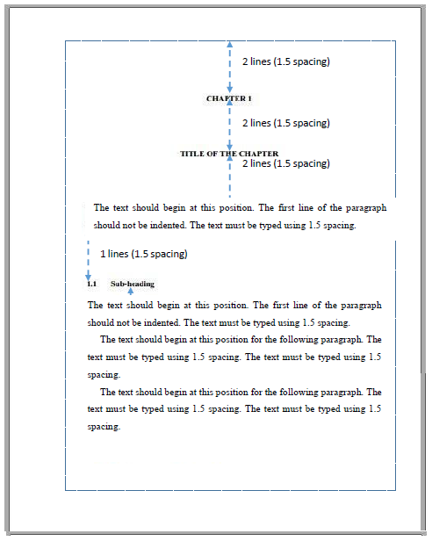 | - Language: The thesis is written entirely in English or Bahasa Melayu. The language used is consistent throughout, especially regarding spelling (either American or British).  - Paper Specifications: White simile A4 size (210 mm x 297 mm) paper of 80 gram equivalent quality is used.  - Margins: All pages have the same margins: 4 cm for the left margin (for binding) and 2.5 cm for the right, top, and bottom margins. All tables and figures are placed within these specified margins.  - Typing: The thesis is typed using Microsoft Word or similar software. The same font or typeface is used throughout the thesis, including headings, page numbers, captions, and references.  - Font Type and Size: Times New Roman is the required font type. The font size for the main text is 12-point. The font is not scripted or italicised, except for scientific names and terms in a different language8.  - Bold Print: Bold print is used for headings8.  - Footnotes and Table Text: Font size for footnotes and text in tables is not less than 8-points8.  - Mathematical Text: Equation Editor is used for mathematical texts.  - Pagination: All pages, including those with tables, figures, references, and appendices, are counted and numbered consecutively. Page numbers are printed at the top right-hand corner, 1.25 cm from the top edge and 2.5 cm from the right edge, without any punctuation. The pagination font is Times New Roman 10-points.  - No page number for the first page of each chapter. Page 1 is the first page of Chapter 1, but the page number is not typed on this first page, nor on the first page of any other chapter, although they are counted.  - Page Layout: The preliminary section, text, and supporting section are presented in portrait layout. Landscape layout may be used for figures, tables, and appendices if necessary.  - Citations in the text must be in the reference list  - No indent for the first paragraph of each section  - Tables: Numbered using Arabic numerals sequentially throughout the thesis, labelled by chapter (e.g., Table 4.1). Each table has a caption placed above it. Single-line captions are centred; multi-line captions are aligned to the left. All tables are referred to in the text. Table sources and notes are placed directly below the table before the caption (if applicable).  - Figures: Numbered using Arabic numerals sequentially by chapter (e.g., Figure 3.6). Figures are clear and high quality. Each figure has a caption typed using single spacing, centred, and placed below the figure. Multi-line captions are aligned to the left. All figures are referred to in the text. Figure sources and notes are placed directly below the figure before the caption (if applicable).  - Equations: Written using Equation Editor. Numbered according to the chapter. Equation numbers are enclosed by parentheses and placed at the right-hand side of the page. Parameters in equations are italicised (not units and numbers) and defined on their first appearance. Equations are consistently indented or centred. Detailed derivations are placed in the appendix.  - Citation and Referencing. A citation style appropriate to the field is chosen and used correctly and consistently throughout the thesis. For every in-text citation, there is a corresponding full citation in the Reference List, and vice versa.  - Word Limits: The thesis adheres to the prescribed word limits for the programme of study, which apply to the text ONLY (excluding preliminary sections, tables, figures, captions, footnotes, references, appendices, and list of publications).  - Approval from the postgraduate committee is needed if the thesis is significantly under or over the recommended limit.  - Project Paper:  - Master (20,000-30,000 words),  - Doctorate (30,000-40,000 words).  - Dissertation:  - Master (40,000-60,000 words),  - Doctorate (60,000-100,000 words).  - Thesis:  - Master (30,000-50,000 words),  - Doctorate (50,000-80,000 words).  - Spacing: The general text of the thesis uses 1.5 spacing. Single spacing is permitted in the preliminary section, tables, multi-line captions, long quotations, footnotes, and the supporting section (references, appendices, list of publications). Specific spacing rules are followed between sections (e.g., 1.5 spacing between chapter number/title and text, no spacing between sub-section title and text, 1.5 spacing between text and sub-section title). A new paragraph does not start at the bottom of a page with only one line of space available.  - Numbering Sections and Sub-sections: Chapters are numbered using Arabic numerals (e.g., CHAPTER 1, CHAPTER 2). Chapter titles are typed with capital letters, bold, and centred.  - Each chapter begins on a new page. Sub-section numbers and titles are bold, capitalised each word, and aligned with the left margin. Sub-section numbering is nested (up to 4 levels) but not indented. If a sub-section title exceeds a single line, it uses single spacing between the lines.  - Printing: Printing is done on only one side of a sheet. A high-quality laser or ink-jet printer is used. All figures should be printed in high resolutions (600 dpi).
14 | Page number |  | - All pages should be counted and located at the top right-hand corner  - Standardised the type of font
15 | References |  | - All sources in the reference list must be cited in the text  - The format used must be standardised  - APA 7 is recommended

* Students should use the correct format according to the thesis template. Please refer to the thesis guidelines for further explanations

